Brain Tumor Detection System
Data Modeling

ERD, Class Diagram, Database Schema, and Data Dictionary

Graduation Project — 2026

Table of Contents
Table of Contents 1
1. Data Modeling Overview 1
2. Entity Relationship Diagram (ERD) 1
3. Class Diagram 1
4. Database Schema 1
4.1 Users 1
4.2 PatientProfiles 1
4.3 DoctorProfiles 1
4.4 Scans 1
4.5 Consultations 1
4.6 Messages 1
4.7 Notifications 1
4.8 DoctorRatings 1
5. Data Dictionary 1
5.1 ENUM Definitions 1
5.2 Validation Rules and Constraints 1
5.3 Default Values 1
6. Database Indexes 1

1. Data Modeling Overview
This document presents the complete data modeling for the Brain Tumor Detection and Treatment Suggestion System, covering the Entity Relationship Diagram (ERD), Class Diagram, full database schema with all 8 tables, and the data dictionary defining every ENUM, constraint, and business rule.
This document contains:
- 1 ERD diagram — 8 entities with relationships and cardinality
- 1 class diagram — 8 domain classes with attributes, methods, and inheritance
- 8 database schema tables — every column, type, key, and constraint
- 1 data dictionary — all ENUM values, defaults, and validation rules

2. Entity Relationship Diagram (ERD)
The ERD shows all 8 entities in the system, their attributes (with primary and foreign keys), and the relationships between them with cardinality notation.

Entities: User, PatientProfile, DoctorProfile, Scan, Consultation, Message, Notification, DoctorRating

Key relationships:
- User (1) ↔ (0..1) PatientProfile — each user can optionally have a patient profile
- User (1) ↔ (0..1) DoctorProfile — each user can optionally have a doctor profile
- PatientProfile (1) ↔ (0..*) Scan — a patient can have many scans over time
- Scan (1) ↔ (0..*) Consultation — a scan can lead to multiple consultations with different doctors
- Consultation (1) ↔ (0..*) Message — a consultation can have many messages (patient-doctor chat)
- Consultation (1) ↔ (0..1) DoctorRating — a consultation can have at most one rating from the patient
- DoctorProfile (1) ↔ (0..*) DoctorRating — a doctor accumulates ratings across consultations
- User (1) ↔ (0..*) Notification — each user receives notifications for various events

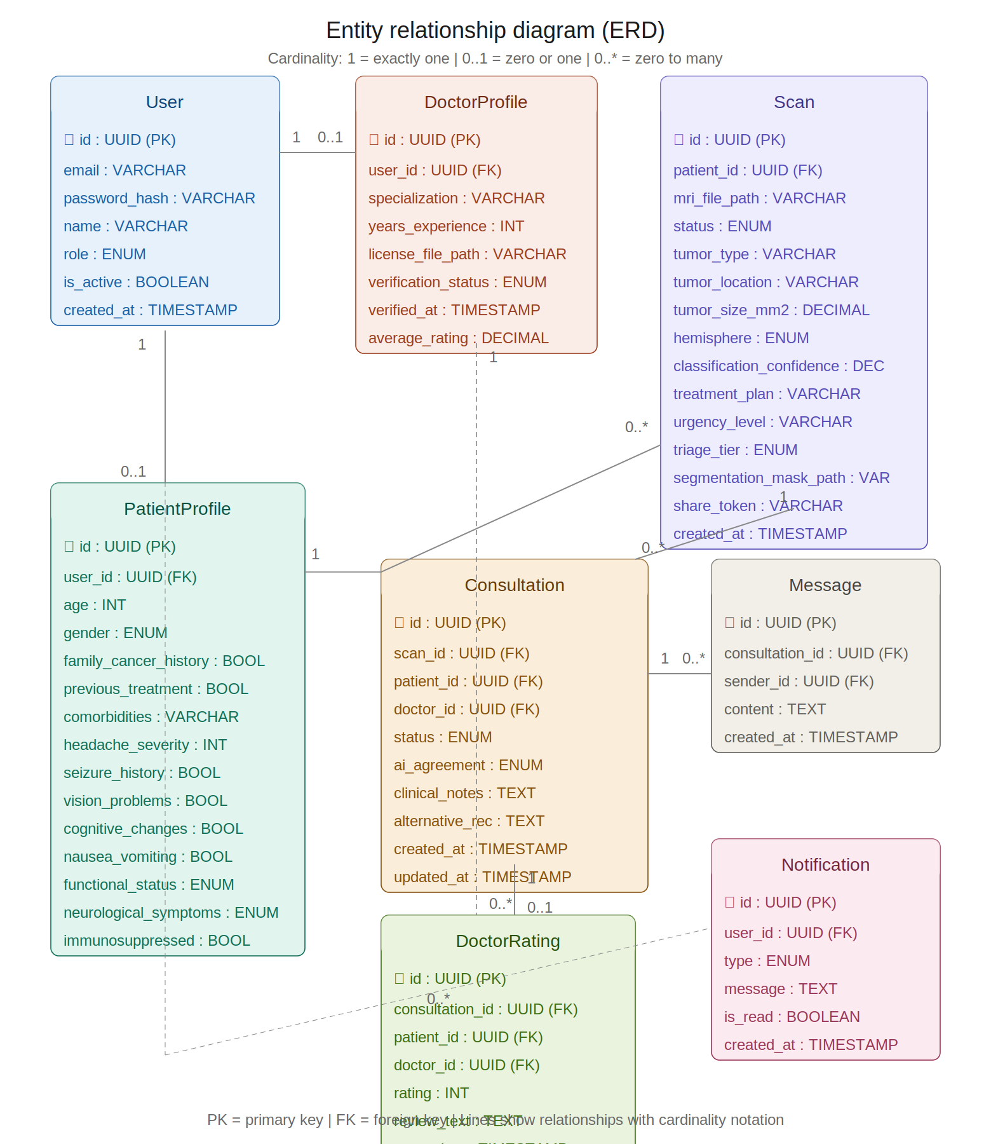
Figure 2.1 — Entity relationship diagram

3. Class Diagram
The class diagram shows the domain model with 8 classes, their attributes (private, prefixed with –), methods (public, prefixed with +), and relationships including inheritance, association, and composition.

Inheritance hierarchy:
- User is marked as «abstract» — it cannot be instantiated directly. It holds shared attributes (id, email, password_hash, name, role, is_active) and shared methods (register, login, resetPassword, deactivate).
- Patient extends User — adds 7 health-related attributes from the intake form and 5 patient-specific methods (fillIntakeForm, uploadMRI, viewResults, bookConsultation, rateDoctor).
- Doctor extends User — adds 5 professional attributes (specialization, license, verification status) and 5 doctor-specific methods (registerWithLicense, acceptConsultation, reviewAIReport, writeClinicalNotes, sendMessage).

Key associations:
- Patient (1) → (0..*) Scan — composition, a patient owns their scans
- Scan (1) → (0..*) Consultation — association, a scan can generate consultations
- Consultation (1) → (0..*) Message — composition, messages belong to a consultation
- Doctor (1) → (0..*) Consultation — association, a doctor handles consultations
- Doctor (1) → (0..*) DoctorRating — aggregation, ratings accumulate for a doctor
- User (1) → (0..*) Notification — association, users receive notifications

Custom types used: Role, Gender, FuncStatus, NeuroSym, VerifStatus, ScanStatus, Hemisphere, TriageTier, ConsultStatus, Agreement, NotifType — all defined in the Data Dictionary (Section 5).

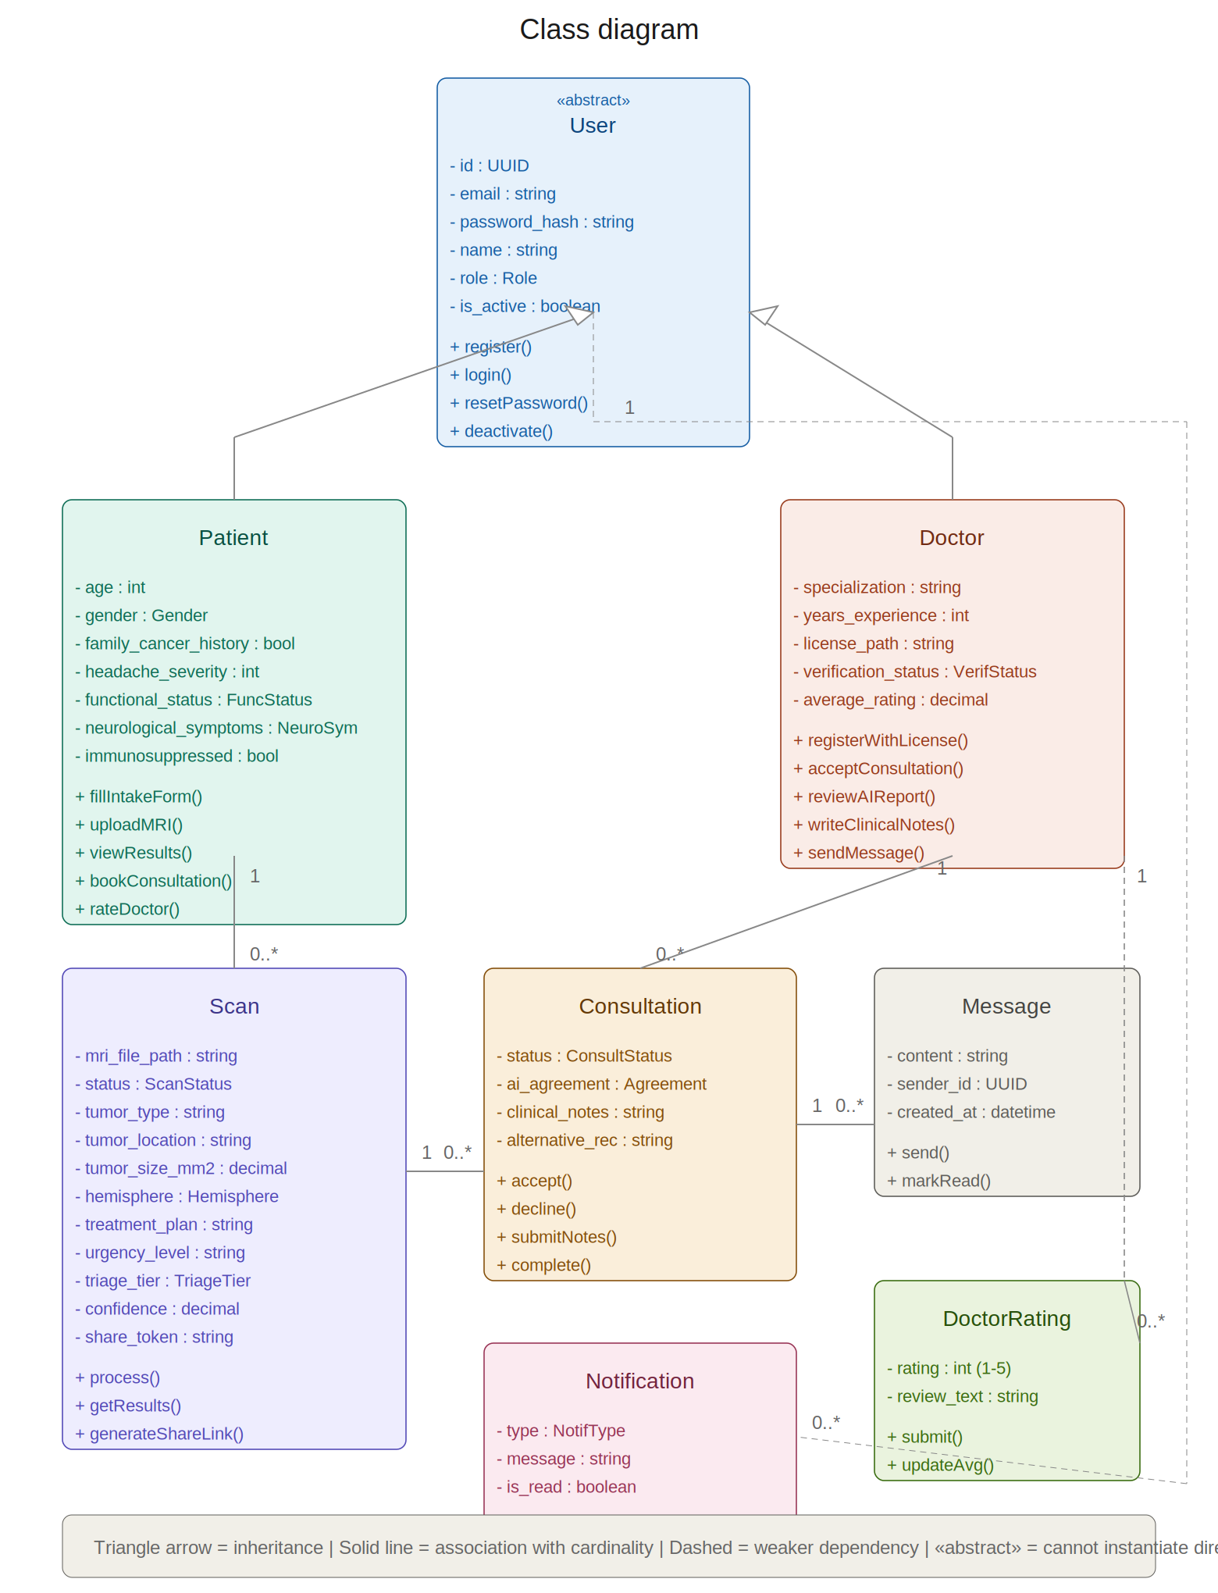
Figure 3.1 — Class diagram

4. Database Schema
Complete schema for all 8 tables. The system uses PostgreSQL (recommended) or MongoDB. All tables include UUID primary keys and timestamp tracking.

4.1 Users
Column | Type | Null | Key | Notes
id | UUID | No | PK | Auto-generated UUID v4
email | VARCHAR(255) | No | UNIQUE | Login identifier, validated format
password_hash | VARCHAR(255) | No |  | bcrypt hash, 12 salt rounds
name | VARCHAR(100) | No |  | Display name
role | ENUM | No |  | patient | doctor | admin
is_active | BOOLEAN | No |  | Default: true
created_at | TIMESTAMP | No |  | Auto-set on creation
updated_at | TIMESTAMP | No |  | Auto-updated on change

4.2 PatientProfiles
Column | Type | Null | Key | Notes
id | UUID | No | PK
user_id | UUID | No | FK → Users | One-to-one, UNIQUE
age | INT | Yes |  | Range: 0-120
gender | ENUM | Yes |  | male | female
family_cancer_history | BOOLEAN | Yes
previous_treatment | BOOLEAN | Yes |  | Had prior brain tumor treatment
comorbidities | VARCHAR(500) | Yes |  | Free text description
headache_severity | INT | Yes |  | Scale 0-10
seizure_history | BOOLEAN | Yes
vision_problems | BOOLEAN | Yes
cognitive_changes | BOOLEAN | Yes
nausea_vomiting | BOOLEAN | Yes
functional_status | ENUM | Yes |  | See data dictionary
neurological_symptoms | ENUM | Yes |  | See data dictionary
immunosuppressed | BOOLEAN | Yes |  | Plain language question

4.3 DoctorProfiles
Column | Type | Null | Key | Notes
id | UUID | No | PK
user_id | UUID | No | FK → Users | One-to-one, UNIQUE
specialization | VARCHAR(100) | No |  | e.g. Neurosurgery, Oncology
years_experience | INT | Yes |  | Range: 0-60
license_file_path | VARCHAR(500) | No |  | Path to uploaded file
verification_status | ENUM | No |  | pending | verified | rejected
verified_at | TIMESTAMP | Yes |  | Set when admin approves
average_rating | DECIMAL(3,2) | Yes |  | Computed from DoctorRatings

4.4 Scans
Column | Type | Null | Key | Notes
id | UUID | No | PK
patient_id | UUID | No | FK → PatientProfiles
mri_file_path | VARCHAR(500) | No |  | Path on disk/blob storage
status | ENUM | No |  | created | processing | completed | failed
tumor_type | VARCHAR(50) | Yes |  | CNN output: glioma | meningioma | pituitary | no_tumor
tumor_location | VARCHAR(100) | Yes |  | Anatomical region from centroid mapping
tumor_size_mm2 | DECIMAL(10,2) | Yes |  | Calculated from mask pixel count
hemisphere | ENUM | Yes |  | left | right
classification_confidence | DECIMAL(4,3) | Yes |  | Range 0.000-1.000
treatment_plan | VARCHAR(255) | Yes |  | ML model output
urgency_level | VARCHAR(50) | Yes |  | ML model output
triage_tier | ENUM | Yes |  | emergency | urgent | routine
segmentation_mask_path | VARCHAR(500) | Yes |  | Path to overlay image
share_token | VARCHAR(64) | Yes | UNIQUE | For secure sharing links
created_at | TIMESTAMP | No

4.5 Consultations
Column | Type | Null | Key | Notes
id | UUID | No | PK
scan_id | UUID | No | FK → Scans
patient_id | UUID | No | FK → PatientProfiles
doctor_id | UUID | No | FK → DoctorProfiles
status | ENUM | No |  | pending | accepted | declined | in_progress | completed
ai_agreement | ENUM | Yes |  | agree | partially_agree | disagree
clinical_notes | TEXT | Yes |  | Doctor free-text assessment
alternative_recommendation | TEXT | Yes |  | Filled when disagree/partial
created_at | TIMESTAMP | No
updated_at | TIMESTAMP | No

4.6 Messages
Column | Type | Null | Key | Notes
id | UUID | No | PK
consultation_id | UUID | No | FK → Consultations
sender_id | UUID | No | FK → Users | Can be patient or doctor
content | TEXT | No |  | Message body
created_at | TIMESTAMP | No |  | Chronological ordering

4.7 Notifications
Column | Type | Null | Key | Notes
id | UUID | No | PK
user_id | UUID | No | FK → Users | Recipient
type | ENUM | No |  | See data dictionary
message | TEXT | No |  | Human-readable notification text
is_read | BOOLEAN | No |  | Default: false
reference_id | UUID | Yes |  | Links to scan/consultation/etc
created_at | TIMESTAMP | No

4.8 DoctorRatings
Column | Type | Null | Key | Notes
id | UUID | No | PK
consultation_id | UUID | No | FK → Consultations | UNIQUE (one rating per consult)
patient_id | UUID | No | FK → PatientProfiles
doctor_id | UUID | No | FK → DoctorProfiles
rating | INT | No |  | Range: 1-5 stars
review_text | TEXT | Yes |  | Optional written review
created_at | TIMESTAMP | No

5. Data Dictionary
This section defines all ENUM types, constraints, validation rules, and default values used across the database schema. Developers must implement these exact values in the application code.

5.1 ENUM Definitions
ENUM Name | Allowed Values | Usage
Role | patient | doctor | admin | Users.role — determines access level and UI shown
Gender | male | female | PatientProfiles.gender — used in treatment model input
FunctionalStatus | independent | needs_some_help | needs_significant_help | fully_dependent | PatientProfiles.functional_status — proxy for KPS score. Mapped to numeric values for the ML model.
NeurologicalSymptoms | none | mild | moderate | severe | PatientProfiles.neurological_symptoms — proxy for neurological deficit examination
VerificationStatus | pending | verified | rejected | DoctorProfiles.verification_status — controls doctor visibility to patients
ScanStatus | created | processing | completed | failed | Scans.status — tracks scan lifecycle. See state diagram ST-01.
Hemisphere | left | right | Scans.hemisphere — determined from segmentation mask centroid x-position
TriageTier | emergency | urgent | routine | Scans.triage_tier — ML model output. Maps to red/amber/green banner colors.
ConsultationStatus | pending | accepted | declined | in_progress | completed | Consultations.status — see state diagram ST-02
AgreementLevel | agree | partially_agree | disagree | Consultations.ai_agreement — doctor assessment of AI suggestion accuracy
NotificationType | scan_completed | consultation_requested | consultation_accepted | consultation_declined | notes_available | new_message | doctor_verified | Notifications.type — determines notification icon and routing

5.2 Validation Rules and Constraints
Field | Constraint | Business Rule
Users.email | UNIQUE, NOT NULL | Must be valid email format. Used as login identifier. Cannot be changed to an email that already exists.
Users.password_hash | NOT NULL | Minimum 8 characters before hashing. Must include uppercase, lowercase, and number. Stored as bcrypt with 12 salt rounds.
PatientProfiles.age | CHECK (0-120) | Must be a positive integer. Used as input to treatment suggestion model.
PatientProfiles.headache_severity | CHECK (0-10) | Integer scale. 0 = no headache, 10 = worst possible. Used as model input.
DoctorProfiles.license_file_path | NOT NULL | File must be PDF, JPEG, or PNG. Maximum size 10MB. Stored on disk/blob storage.
Scans.mri_file_path | NOT NULL | Accepted formats: JPEG, PNG. Maximum 50MB. Stored on disk/blob storage, path saved in DB.
Scans.tumor_size_mm2 | DECIMAL(10,2) | Calculated from segmentation mask pixel count. Unit is always mm² (not cm², not volume).
Scans.classification_confidence | DECIMAL(4,3), 0.000-1.000 | Output from CNN softmax layer. Displayed as percentage to patient (e.g., 0.943 = 94.3%).
Scans.share_token | UNIQUE, VARCHAR(64) | Generated using crypto-random 32 bytes, hex-encoded. Enables public access to specific results without auth.
DoctorRatings.rating | CHECK (1-5) | Integer star rating. Doctor average_rating is recomputed on each new rating submission.
Consultations.ai_agreement | NULL until notes submitted | Required when doctor submits clinical notes. Cannot be changed after submission.

5.3 Default Values
Field | Default | Notes
Users.is_active | true | Set to false on deactivation. Prevents login but preserves data.
Users.role | patient | Default for standard registration. Doctor role set via doctor registration flow.
DoctorProfiles.verification_status | pending | All new doctor registrations start as pending until admin reviews.
Scans.status | created | Set on initial record creation. Transitions to processing when forwarded to FastAPI.
Consultations.status | pending | Set when patient books. Transitions based on doctor actions.
Notifications.is_read | false | Toggled to true when user clicks or opens the notification.

6. Database Indexes
Recommended indexes for query performance. These should be created after the initial schema migration.
Table.Column(s) | Index Type | Reason
Users.email | UNIQUE B-Tree | Login lookups, duplicate checks
PatientProfiles.user_id | UNIQUE B-Tree | Profile lookups by user
DoctorProfiles.user_id | UNIQUE B-Tree | Profile lookups by user
DoctorProfiles.verification_status | B-Tree | Admin queue filtering (WHERE status = pending)
Scans.patient_id | B-Tree | Patient scan history listing
Scans.share_token | UNIQUE B-Tree | Public share link lookups
Consultations.patient_id | B-Tree | Patient consultation list
Consultations.doctor_id | B-Tree | Doctor dashboard queries
Consultations.status | B-Tree | Filtering by status (pending requests)
Messages.consultation_id, created_at | Composite B-Tree | Chat message ordering within consultation
Notifications.user_id, is_read | Composite B-Tree | Unread notification count badge

